SICILY – ITALY
Tuesday 16th MAY 2017 - Wednesday 31st MAY 2017 ( 16 days)
Ev Hales – Watercolour and Sketching Workshop
16th May  Tuesday  Day1 | PALERMO  Arrival at the airport for pickup to our hotel located in Selinunte – Kartibubbo in Torretta.  Transfer will be arranged around 10.30 am and 3.00 pm approximately.  Meet and greet at 6.30 pm in our hotel with dinner to follow 7.00 pm  (D) Kartibubbo in Torretta
17th May  Wednesday  Day2 | SELINUNTE  Enzo our guide will lecture about the ancient Greek colonization in Sicily and the Roman age while we are transferred to the archaeological park of Selinunte. One of the most important Greek colonies in Sicily situated on the southwest coast of the island. Nowadays one of the largest and most impressive archaeological sites in the Mediterranean. Visit by electric cars are an option.  Free time for lunch on the beach of Marinella di Selinunte. In the afternoon back to the archaeological park to paint the temples.  (B,D) Karibuddo in Torretta | 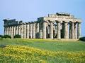
18th May  Thursday  Day 3 | MOZIA and SALT ROAD  Departure to the lagoon of the stagnone for a boat ride to Mozia., settled by the Phoenician in 8th century BC  Paint the location and lunch locally before leaving to drive along the famous “Salt Road” to enjoy a painting session along the incredible scenery of dazzling salt pans dotting with windmills.  (B,D) Karibuddo in Torretta | 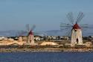
19th May  Friday  Day 4 | TRAPANI  A beautiful town on the coast. It has a colourful fishing port with arabic and spanish elements in its baroque style buildings which will give the artist many options to paint and explore.  Lunch at a local trattoria. Afternoon time to paint the township with its narrow side streets which open into charactacteristic squares.  (B,D) Karibuddo in Torretta | 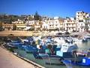
20th May  Saturday  Day 5 | PALERMO & MONREALE  The capital of Sicily will be revealed by Enzio who will relate the history and take us for a sight seeing stroll to discover its best monuments, churches and interesting sections of this city. Time for quick drawings as we rest at a café or shady square.  Departure for lunch to Monreale a small town with historical importance because of its impressive cathedral built during the Norman age, famous in the world for the mosaics that coveres its interior walls.  (B,D) Karibuddo in Torretta | 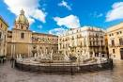
21st May  Sunday  Day 6 | ERICE  We will reach this fascinating medieval town by cable car. The sober historic town is surrounded by defensive town walls crowned by a castle, and dominates the surrounding area from its mountainous height of approximately 750 meters above sea level. Tour of the town and settle for some painting time.  Free time for lunch.  Afternoon dedicated to paint the wonderful sceneries offered by the town and its landscapes. Return by cable car to return to our bus.  (B,D) Karibuddo in Torretta | 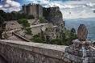
22nd May  Monday  Day 7 | MARSALA  Travel to visit and paint the traditional fish market and the historical picturesque baroque town which till have the ancient roman gates to the old town.  Lunch at Leisure.  Afternoon time to discover another aspect of the town to paint or follow our guide Enzo to view various options  Return to our hotel to organize your luggage for departure in the morning.  (B,D) Karibuddo in Torretta | 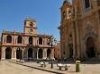
23rd May  Tuesday  Day 8 | Valley of the Temples ( Agrigento)  Bring along your sketch books for a travel day as we depart to visit an exceptional historical archaeological park testimony to “Magna Graecia” presence in this area. This site is an UNESCO World heritage listed. It recount a millenary history began in 6Century BC.  Time for drawing or exploring before leaving to lunch along the way to Modica  Viewing and exploring Modica with time to taste the famous chocolate and tea before leaving for our hotel located at Ragusa  (B,D) Poggio Di Sole | . 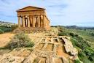
24th May  Wednesday  Day 9 | NOTO  According to legend Noto was founded in 448BC. It is one of the most beautifully built towns in Europe. Noto is famous for its fine C18 honey coloured buildings considered masterpieces of original Sicilian baroque style which were constructed after the tragic 1693 earthquake which totally destroyed the town. The painters will have time to capture their surroundings  Lunch will be at a local tavern. Time in the afternoon to paint and explore.  Return to our hotel to prepare your luggage for departure in the morning  (B,D) Poggio Di Sole | 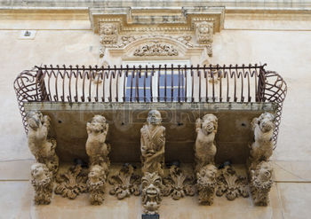
25th May  Thursday  Day 10 | ORTIGIA  It is a beautiful island separated from the main land by a narrow channel but connected with two bridges. The Piazza del Duomo and Archimede created a popular place for the people to gather for entertainment and shopping. Lunch at a local trattoria and then time to paint in the afternoon before leaving for our new hotel in Catania  ( B, D) Le Dune | 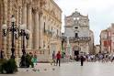
26th May  Friday  Day 11 | SAVOCA  A quiet day to immerse in the timelessness of the Sicily’s countryside. We are in a small traditional Sicilian village made famous because it was the location for some scenes of the “Godfather”. Artists will paint near the Bar Vitelli , the place where Michael Corleon asked Apollonia’s father to meet his daughter.  After lunch a visit to the surround area including the stunning Alcantara Gorges with its clear and cold waters.  ( B, D) Le Dune | 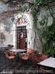
27th May  Saturday  Day 12 | ETNA visit & NAXOS  Departure for Etna the largest volcano in Europe and the tallest mountain in Sicily. The big mountain which the ancients thought to be the forge of the god Vulcan and Cyclops always influenced the life of the people living in the surrounding area. We will be driven thought the National Park to walk and view from the mountain the cities and sea below.  We will lunch at Naxos fishing sea town . In the afternoon we can paint the harbor of Naxos , the first Greek settlement with views of the coastline mountains with a sapphire sea.  ( B, D) Le Dune | 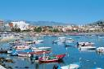
28th May  Sunday  Day 13 | ACI TREZZA  This will be a quiet day with views called the Cyclopes Riviera.  The village has a long maritime history and a story of Odysseus and  the one eyed Cyclops. The Faraglioni rocks and Ionian sea will be our settling.  Lunch at your leisure and time to explore.  ( B, D) Le Dune | 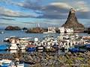
29th May  Monday  Day 14 | TAOMINA  This beautiful historical baroque hilltop town will provide spectacular panoramas , beautiful gardens and evidence of its ancient past with a Greco-Roman theatre built in the 3 Century with views of Mt Etna in the distance and the sea below.  Lunch at leisure. We will have time to paint and draw after exploring the main shopping road.  ( B, D) Le Dune | 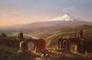
30th May  Tuesday  Day 15 | CATANIA  The city has had a long and eventful history which made it one of Italy’s important and flourishing cultural, artistic and political areas. Because of the location near Mt Etna the city has been buried 17 times.  We will have time to shop and explore with our guide Enzo who enjoys relating the history of Sicily to everyone.  Bring your sketch book for quick drawings.  Return to our hotel to organize your luggage for departure in the morning.  ( B, D) Le Dune | 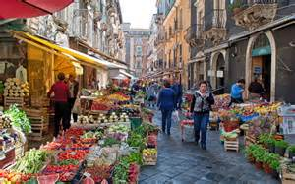
31st May  Wednesday  Day 16 | Departure for Catania airport or train station in the morning for you to continue on your journey.  ( B,) Le Dune
Please note: to ensure you have the tour of a lifetime, the itinerary may be changed at anytime.
(B = Continental Breakfast, D = Dinner) Town of sleeping
Paesano Tours - Janette Garbuio & Marina Cook
(03) 9758 5985 or 0418 309 753
info@paesanotours.com www.paesanotours.com

